Point Light

📘 Definition
# Source: AI Source: Provided by: [Data Path: Persons Table -> ID Column: 1, Name_En Column: Motasem Essam] -> From: [ChatGPT] on [5/2/2026]
A Point Light is a type of light source in computer graphics that emits light equally in all directions from a single point, like a light bulb.

💡 How Point Light works
# Source: AI Source: Provided by: [Data Path: Persons Table -> ID Column: 1, Name_En Column: Motasem Essam] -> From: [ChatGPT] on [5/2/2026]
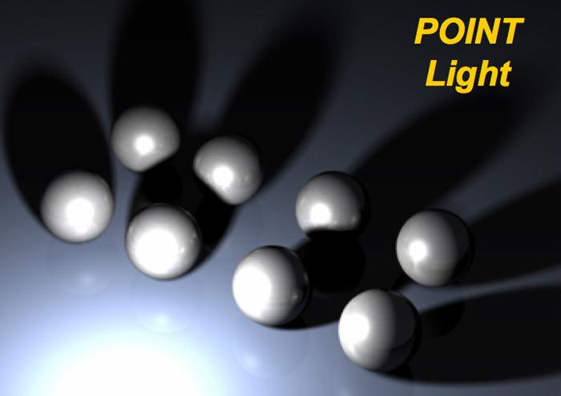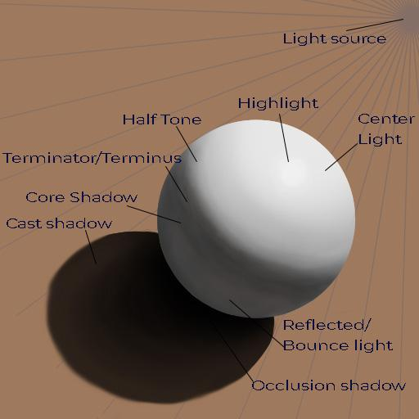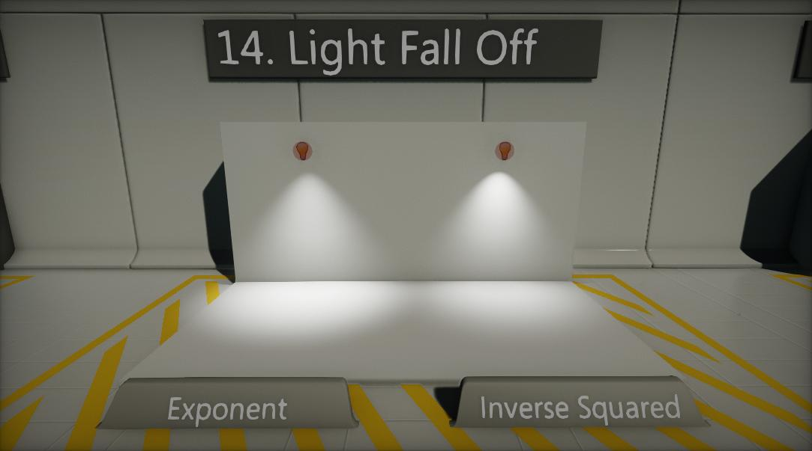
- The light comes from one fixed position
- It spreads out in all directions (360°)
- Objects closer to the light appear brighter
- Objects farther away appear darker (this is called light falloff)

🧠 Simple example
# Source: AI Source: Provided by: [Data Path: Persons Table -> ID Column: 1, Name_En Column: Motasem Essam] -> From: [ChatGPT] on [5/2/2026]
Think of:
- 💡 A light bulb hanging in a room
- 🔥 A candle in a dark space
Everything around it gets light, but the brightness decreases with distance.

🎮 Where Point Light is used
# Source: AI Source: Provided by: [Data Path: Persons Table -> ID Column: 1, Name_En Column: Motasem Essam] -> From: [ChatGPT] on [5/2/2026]
- Video games (lamps, torches, glowing objects)
- 3D animation and movies
- Interior lighting in virtual scenes
- Simulations (scientific or architectural models)

⚙️ Key features
# Source: AI Source: Provided by: [Data Path: Persons Table -> ID Column: 1, Name_En Column: Motasem Essam] -> From: [ChatGPT] on [5/2/2026]
- 📍 Has a single position in space
- 🌐 Emits light in all directions
- 🌑 Creates realistic shadows and depth
- 📉 Uses distance-based fading (attenuation)

🚀 In short:
# Source: AI Source: Provided by: [Data Path: Persons Table -> ID Column: 1, Name_En Column: Motasem Essam] -> From: [ChatGPT] on [5/2/2026]
Point Light = a light source that shines in all directions from one point, like a bulb or candle.

